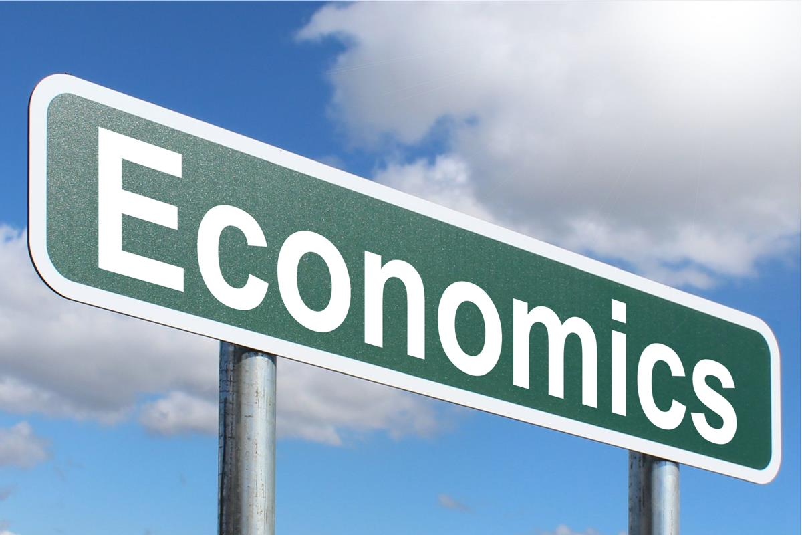

UNIT III & IV

GENERAL STUDIES III

SHIVAM AWAD | ECONOMICS | 2024

**INDUSTRIAL DEVELOPMENT IN INDIA**

# Industrial development in India

**Phases of Industrial Development in India**

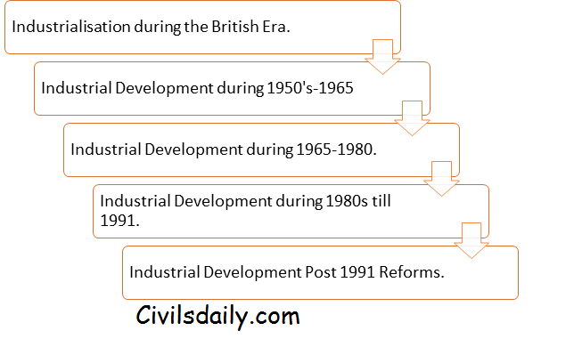

**Industrialisation during the British Rule**

Indian Industry had a global presence before the advent of Britishers in India. Before the advent of British in India, India accounted for a quarter of World’s Industrial output.

The exports from India consisted of manufacturers goods like cotton, silk, artistic ware, silk and woollen cloth.

The impact of British Policies and the Industrial Revolution led to the decay of Indian handicraft industry. Post-Industrial revolution in Britain, machine-made goods starting flooding into the Indian markets.

The decline of traditional handicraft was not followed by the rise of modern Industrialisation in India due to the British policy of encouraging the imports of British made goods and exports of raw materials from India.

**The First Phase (1950-1965): Industrial Sector at the Time of Independence**

The main features of the Indian Industrial sector on the eve of the Independence were:

1. There were majority of consumer goods industries vis-à-vis producer goods/capital goods industries resulting in lopsided industrial development. The ratio of consumer goods industries to producer good/capital goods industry was 62:38 during the early 1950s.
2. The Industrial sector was extremely underdeveloped with very weak infrastructure.
3. The lack of government support to the industrial sector was considered as an important cause of underdevelopment.
4. The structure and concentration of ownership of the industries were in few hands.
5. Technical and Managerial skills were in short supply.

As a result of these shortcomings, the national leadership reached on a consensus that economic sovereignty and economic independence lay in the rapid industrialisation including the development of Industrial Infrastructure.

The **First Five-year Plan** did not envisage any large-scale programs for industrialisation. The plan rather made an attempt to give a practical shape to the Indian economy by providing for the development of both private and public sector. A number of industries were set up in the public sector. Important among those were Hindustan Shipyard, Hindustan Tools, Integral Coach Factory etc.

The **Second Five-Year plan** accorded highest priority to Industrialisation. The plan was based on famous Mahalanobis Model. Mahalanobis model set out the task of establishing basic and capital goods industries on a large scale to create a strong base for the industrial development. The plan includes substantial investment in the Iron and Steel, Coal, Heavy engineering, Machine building, Heavy Chemicals and Cement Industries of basic importance.

The **Third Plan** followed the strategy of the Second plan by establishing basic capital and producer good industries with the special emphasis on machine building industries. As a result, the second and the third plan placed great emphasis on building up the capital goods industries. Most of the capital good industries are built under the Public Sector.

The First Three-Five Year Plans are important because their aim was to build a strong Industrial base in India. This first phase of Industrial development in India laid the foundation for strong Industrial Phase.

As a result, the first Three Plans witnessed a strong acceleration in the growth rate of the Industrial production. The period witnessed an increase in growth rate from 5.7% to 7.2% and ultimately 9.0% in the first, second and third plans respectively.

The most important observation of the period was that the rate of growth of capital good industry considered as the backbone of modern industrialisation grew at 9.8%, 13.1% and 19% during the first, second and third plan respectively.

###### https://d18x2uyjeekruj.cloudfront.net/wp-content/uploads/2017/10/word-image1.png Source: Government of India, Handbook of Industrial Statistics

**The Second Phase (1965-1980): The Period of Industrial Deceleration**

The first three five-year plans mostly focused on the development of the Capital Good sector. As a result, the consumer goods sector was left neglected. The consumer goods sector also known as wage good sector is considered to be the backbone of the rural economy and its complete neglect had resulted in fall in the growth rate of industrial

production as well as of the overall economy.

**Note4Student**

**The Wage Good Model:**Prominent Economist like, C N Vakil and P R Brahmananda advocated Wage Good model for the development of the Indian economy and Industrialisation. Vakil and Brahamanda differed from the Mahalanobis strategy as they believe “At the low level of consumption (this was the situation in India) the productivity of the workers depends on how much they consumed. According to them, if people were undernourished, they will lose their productivity and become less efficient, at this juncture it is necessary to feed them to increase their productivity. But this is not true for all consumer good; so they differentiated between Wage Good (whose consumption increase worker productivity) and Non-Wage Good (whose consumption did not).

To sum up, Wage Good model says; worker’s productivity depends on not on whether they use machines to produce goods but also on the consumption of wage goods like, food, cloth and other basics. Therefore, the first step towards development is to mechanize agriculture and raise food production; once this objective is reached, one should go for Mahalanobis strategy of Heavy Industrialisation.

Anyway, Vakil and Bharmananda strategies were ignored and India launched heavy Industrialisation in the Second plan without mechanising agriculture. The result was failure of Mahalanobis Strategy and by 1965-66 India was hit by a severe food shortage crisis. Finally, in the wake of the crisis, the government adopted Bharamananda strategy of mechanizing agriculture sector and engineered green revolution.

The period between 1965 to 1975 was marked by a sharp fall in the industrial growth rate. The rate of growth fell from 9.0% during the third plan to a mere 4.1% during the period of 1965-75. The growth rate fell to 5.3% in 1965-66, 0.6% in 1966-67, then recovering a little in the succeeding years.

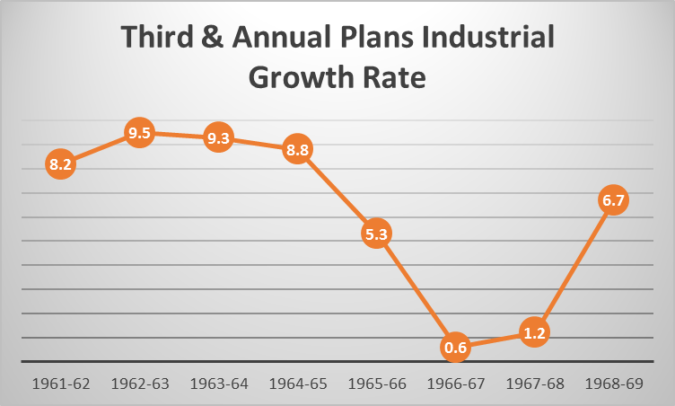

###### Source: Ministry of Commerce, GOI.

###### https://d18x2uyjeekruj.cloudfront.net/wp-content/uploads/2017/10/word-image3.png Source: Ministry of Commerce, GOI.

The deceleration it the growth rate is evident during the fourth and fifth plan. The industrial growth rate fell from 5.6% in the year 1971-72 to 0.8% in the year 1973-74. At the end of the fifth plan in 1979-80, the industrial growth rate fell to negative 1.6%.

The period of 1965-80 is also marked as the period of structural retrogression, where the growth rate of the capital good sector and basic industries also fell.

**Causes of Deceleration and Retrogression.**

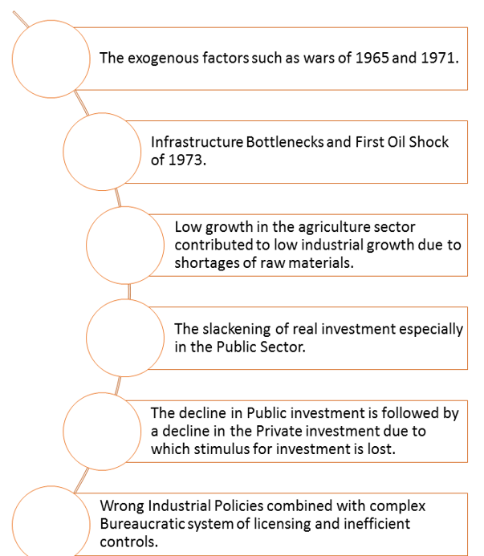

**Phase Three (1980-1991): Industrial Recovery**

The period of the 1980s can be considered as the period of the Industrial recovery. The period saw a revival in the industrial growth rates. The period witnessed an industrial growth rate of more than 6 percent during the sixth plan and 8.5 percent during the seventh plan. The period was also marked by a significant recovery in the manufacturing and capital good sector. The most important observation from the revival of industrial sector was that the revival is closely associated with the increase in the productivity of Indian Industries.

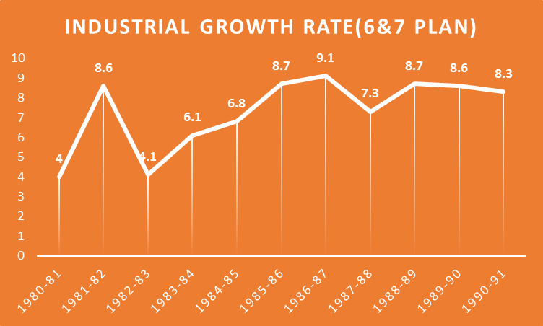

###### Source: Ministry of Commerce, GOI.

**Causes of Industrial Recovery**

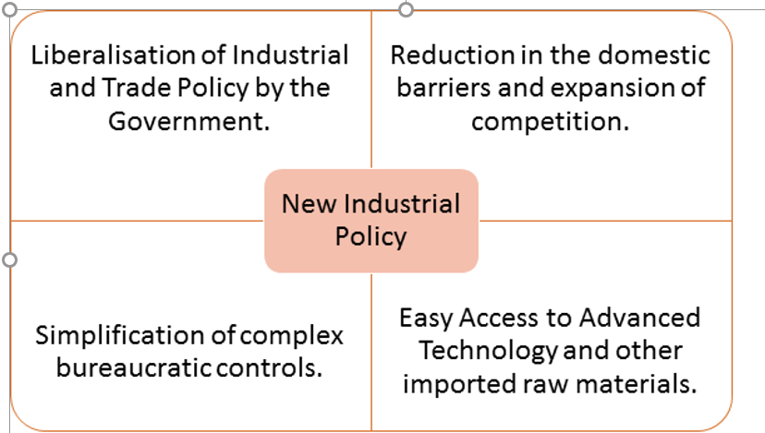

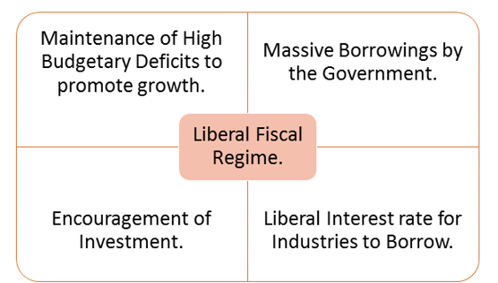

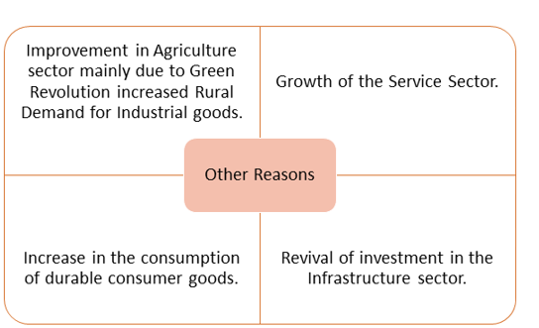

**Phase Four (Post Reform Period)**

The year 1991 ushered a new era of economic liberalisation. India took major liberalisation decision to improve the performance of the industrial sector.

1. Abolishment of the Industrial Licensing.
2. Simplification of the procedures and regulatory requirement to start a business.
3. Reduction in the sector exclusively reserved for the Public sector.
4. Disinvestment of the selected Public-sector undertakings.
5. Foreign investors were allowed to invest in the Indian firms.
6. Liberalisation of the trade and exchange rate policies.
7. Rationalisation and massive reduction in the structure of Customs Duties.
8. Reduction in the excise duties.
9. Reduction in the Income and Corporate taxes to promote Business.

To analyse the impact of these reforms measures on the industrial growth, it is better to divide the period into two.

**The period of the 1990s**

1. The average annual growth rate of the industry which was close to 8% in the post-reform period fell to 6% in the 1990s.
2. The growth rate in the Eighth Plan was 7.3 percent which was same as the targeted growth rate.
3. The growth rate in the Ninth Plan was 6.0 percent which was significantly less than the targeted rate of 8.2 percent.
4. Further, the sector witnessed its worst ever performance in the last few years of the Ninth plan with growth collapsing to just 2 percent.

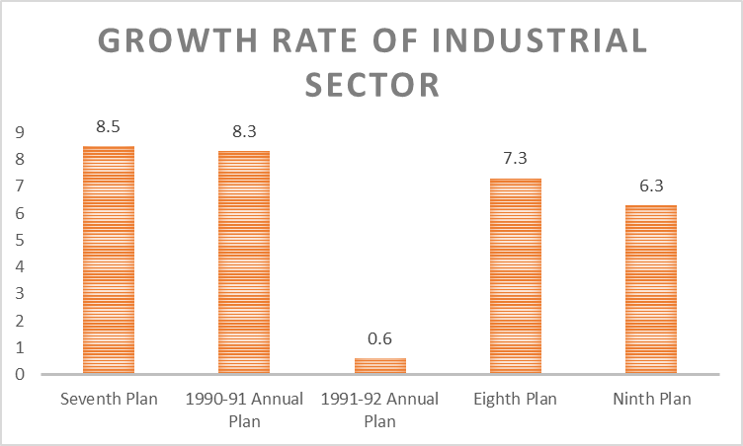

##### Source: Ministry of Commerce, GOI.

**Causes of Slow Industrial Performance.**

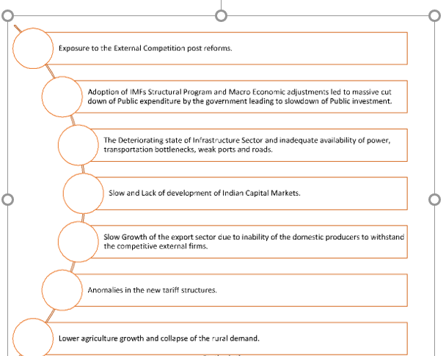**The Period since 2002-03:**

The period since the new millennium witnessed a sharp recovery and revival of the industrial sector. The tenth and eleventh plan witnessed a high growth rate of industrial production.

The rate of growth of the industrial sector was 5 percent during the initial years of the Tenth Plan. The growth picked in the following years and reached 7% in 2003-04, 8% in 2004-05 and 11% in 2006-07. For the plan as a whole, the growth rate was 8.2 percent.

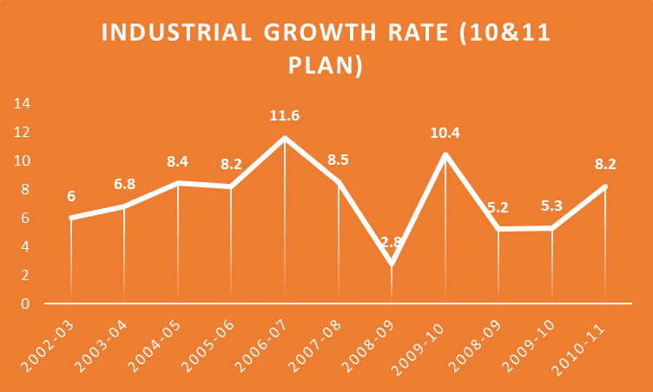

Source: Ministry of Commerce, GOI.

The growth in the Tenth plan was mainly driven by the manufacturing sector. The significant acceleration in the capital good sector was the significant contributor to the

overall economic growth.

During the Eleventh Plan, the industrial growth witnessed a considerable degree of fluctuations. After growing at more than 8 percent, the growth collapsed to 2.8 percent in the year 2008-09. The main reason for the collapse was the Global Financial crisis that hit the World in the year 2008.

The industrial growth started recovering in the year 2009-10 and touched a high of 10 percent. The industrial growth after some setbacks again recovered in the year 2010-11 to reach 8.2 percent.

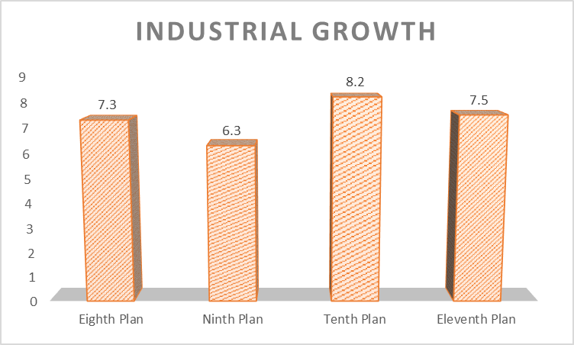

###### Source: Ministry of Commerce, GOI.

**The period post-2011 till now.**

The period starting from 2011-12 saw a severe slowdown in the industrial growth and production. The slowdown during the period is due too.

1. Weak Demand for exports from the Developed Western Countries due to Global Financial Crisis.
2. The slowdown in the Domestic Demand.
3. High Interest in India maintained by the RBI, due to persistently high Inflation.
4. The slowdown in the Private Investment by the private sector due to weak returns on the investments.
5. Rising NPAs of the Public-Sector banks has led to weak credit and lending offered by them.
6. Failure of past projects of the private sector.
7. Government reluctance to increase Public investment due to the stand of maintaining a low fiscal deficit.
8. Uncertain Global Recovery.
9. European Debt Crisis.
10. The slowdown in the prices of commodities in International Commodity markets mainly due to weak Chinese growth. The weakness in the prices has hit the Indian agriculture sector where prices of the Agriculture commodities has remained low, leading to collapse of income in the rural areas.

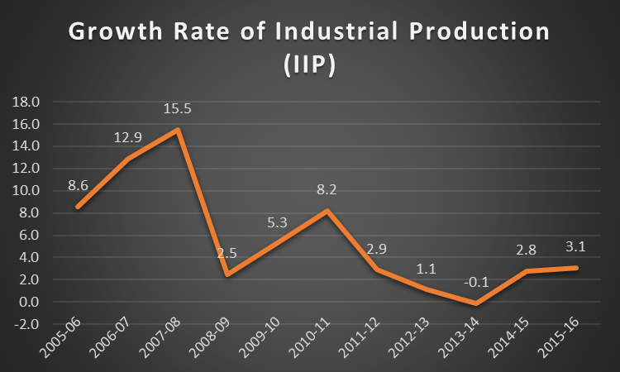 Source: Ministry of Commerce, GOI.

The annual growth rate of IIP has been decelerating post-2011. The IIP fell from 8.2% in 2010-11 to 2.9% in 21011-12. The IIP further fell to 1.1% in 2012-13, negative 0.1 percent in 2013-14 and 2.8% in 2014-15.

**Trends of Plan-Wise Industrial Growth Rate.**

###### https://d18x2uyjeekruj.cloudfront.net/wp-content/uploads/2017/10/word-image14.png Source: Ministry of Commerce, GOI.

## india’s Foreign Trade:

* **Overview:**
  + Foreign trade in India includes all (merchandise + services) imports and exports to and from India and it accounted for **48.8% of India's GDP in 2018**.
  + At the level of the Central Government, trade is administered by the **Ministry of Commerce and Industry.**
  + In 2022, India was the number 15 in total exports, the number 8 in total imports.
  + According to the Commerce Ministry data, **China**was India's top trading partner from 2013-14 till 2017-18 and also in 2020-21.
  + **Before China**, the UAE was the country's largest trading partner. **The US was the largest partner in 2021-22 and 2022-23.**
* **Exports (merchandise):**
  + **The top exports of India are** Refined Petroleum ($86.2B), Diamonds ($25.9B), Packaged Medicaments ($19.5B), Jewellery ($12.6B), and Rice ($11.1B).
  + **It exports mostly to the United States** ($82.9B), United Arab Emirates ($31.6B), Netherlands ($17.6B), China ($15.3B), and Bangladesh ($13.8B).
  + **In 2022, India was the world's biggest exporter**of Diamonds ($25.9B), Rice ($11.1B), etc.
* **Imports (merchandise):**
  + **The top imports of India** are Crude Petroleum ($170B), Coal Briquettes ($58.7B), Gold ($35.8B), Petroleum Gas ($32B), and Diamonds ($26.1B).
  + **It imports mostly from China**($110B), UAE ($51B) and the US ($48.5B), Saudi Arabia ($46.2B), and Russia ($40.4B).
  + **In 2022, India was the world's biggest importer** of Coal Briquettes ($58.7B), Diamonds ($26.1B), Palm Oil ($11.1B), Mixed Mineral or Chemical Fertilizers ($7.88B), and Nitrogenous Fertilizers ($7.37B).

## Latest Trends of India’s Foreign Trade:

* As per the data from the economic think tank GTRI, **China has overtaken the US as India's largest trading partner**, with a total two-way commerce of **$118.4 billion**, in the **FY 2023-24.**
  + India's exports to China rose by 8.7% to $16.67 billion, while imports increased by 3.24% to $101.7 billion.
* On the other hand, exports to the **US**dipped slightly to $77.5 billion, and imports decreased by about 20% to $40.8 billion (the two-way commerce stood at $118.3 billion).
* **The UAE** with USD 83.6 billion, was the third largest trading partner of India. It was followed by **Russia**($65.7 billion), **Saudi Arabia** ($43.4 billion), and **Singapore**($35.6 billion).

## India’s Trade Deficit with its Major Trading Partners:

* **Latest trends:**
  + **India’s trade deficit**with China rose to $85 billion, Russia to $57.2 billion, Korea to $14.71 billion and Hong Kong to $12.2 billion in 2023-24 against $83.2 billion, $43 billion, $14.57 billion and $8.38 billion in 2022-23.
  + **India has a trade surplus** of $36.74 billion with the U.S. in 2023-24 and America is one of the few countries with which India has a trade surplus along with the U.K., Belgium, Italy, France and Bangladesh.
  + **India's total trade deficit** in the last fiscal narrowed to $238.3 billion as against $264.9 billion in the previous fiscal.
* **What can be drawn from these latest trends?**
  + **Imports are not always bad** if a country is importing raw materials or intermediary products to boost manufacturing and exports.
  + However, it can cause the country's currency to **depreciate**because more foreign currency is needed for imports.
  + This depreciation makes**imports more expensive, worsening the deficit and increasing external debt**.
  + This can deplete foreign exchange reserves and signal economic instability to investors, leading to reduced foreign investment.

**What needs to be done to cut the trade deficit?**Boosting exports, reducing unnecessary imports, developing domestic industries, and managing currency and debt levels effectively.

# Foreign Trade of India: Concepts of International Trade

Last updated on July 8, 2024 by [Alex Andrews George](https://www.clearias.com/author/alex-andrews-george/)

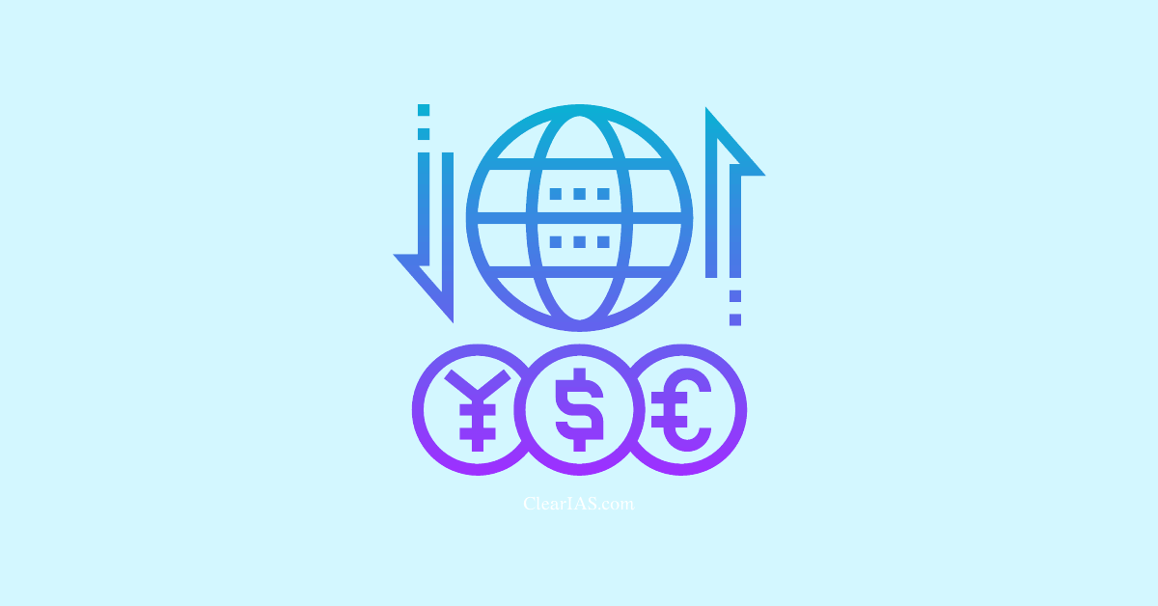**Everything you need to know about the Foreign Trade of India.**

Foreign Trade (International Trade) is all about Exports and Imports.

What is the total value of India’s exports and imports? Which is higher – exports or imports?

What are the main export items? What are the main import items? What are the main export destinations? From which countries does India import the most? What is the trade balance? What is the Current Account Deficit? What is India’s Balance of Payment?

In this post, we explain the must-know concepts of International Trade in India in layman’s language.

Table of Contents

* [Foreign Trade of India](https://www.clearias.com/foreign-trade-of-india/#foreign-trade-of-india)
* [Exports and Imports](https://www.clearias.com/foreign-trade-of-india/#exports-and-imports)
* [Balance of Trade (BoT)](https://www.clearias.com/foreign-trade-of-india/#balance-of-trade-bot)
* [Exports of India: Facts You Need to Know](https://www.clearias.com/foreign-trade-of-india/#exports-of-india-facts-you-need-to-know)
* [Imports of India: Facts you need to know](https://www.clearias.com/foreign-trade-of-india/#imports-of-india-facts-you-need-to-know)
* [Top Trading Partners of India](https://www.clearias.com/foreign-trade-of-india/#top-trading-partners-of-india)
* [Top 10 Export Commodities](https://www.clearias.com/foreign-trade-of-india/#top-10-export-commodities)
* [Top 10 Countries to which India exports the most](https://www.clearias.com/foreign-trade-of-india/#top-10-countries-to-which-india-exports-the-most)
* [Service Exports: Top Services](https://www.clearias.com/foreign-trade-of-india/#service-exports-top-services)
* [Top 10 Import Commodities](https://www.clearias.com/foreign-trade-of-india/#top-10-import-commodities)
* [Top 10 Countries from which India imports the most](https://www.clearias.com/foreign-trade-of-india/#top-10-countries-from-which-india-imports-the-most)
* [Service Imports: Top Services](https://www.clearias.com/foreign-trade-of-india/#service-imports-top-services)
* [Balance of Payments (BoP)](https://www.clearias.com/foreign-trade-of-india/#balance-of-payments-bop)
* [Global Trade](https://www.clearias.com/foreign-trade-of-india/#global-trade)
* [Ease of Doing Business: Performance of India](https://www.clearias.com/foreign-trade-of-india/#ease-of-doing-business-performance-of-india)
* [Logistics Industry in India](https://www.clearias.com/foreign-trade-of-india/#logistics-industry-in-india)
* [Net Remittances from Indians employed overseas](https://www.clearias.com/foreign-trade-of-india/#net-remittances-from-indians-employed-overseas)
* [FDI Inflows and FPI Inflows](https://www.clearias.com/foreign-trade-of-india/#fdi-inflows-and-fpi-inflows)
* [External Debt](https://www.clearias.com/foreign-trade-of-india/#external-debt)
* [Foreign Trade Policy of India](https://www.clearias.com/foreign-trade-of-india/#foreign-trade-policy-of-india)
* [Who regulates Export Trade in India?](https://www.clearias.com/foreign-trade-of-india/#who-regulates-export-trade-in-india)
* [UPSC Question based on International Trade of India](https://www.clearias.com/foreign-trade-of-india/#upsc-question-based-on-international-trade-of-india)

## Foreign Trade of India

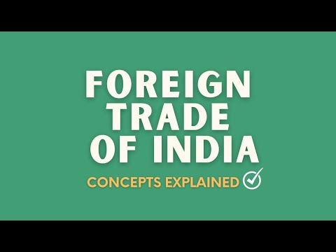

Business with foreign nations is not a new phenomenon in India. India is used to trade with foreign nations even in BC.

The Periplus of the Erythraean Sea is a document (written by an anonymous sailor from Alexandria about AD 100) describing trade between countries, including India.

Since 1498, Europeans have traded with the rulers of India using the sea route. The main export items then were spices like pepper, ginger, cinnamon, cardamom, nutmeg, mace, and cloves.

From 1947-1991, the Indian economy remained largely as a closed economy. High taxes were levied on the import of items. Foreign investments like FDI were restricted.

However, after the liberalization in 1991, foreign trade improved significantly.

## Exports and Imports

Now, India exports around 7500 commodities to about 190 countries, and imports around 6000 commodities from 140 countries. Exports and Imports are not only restricted to commodities (merchandise). Service is also a major export/import item.

To make it simple, let’s summarise foreign trade of India as below:

* Export of goods (merchandise/commodities)
* Export of services
* Import of goods (merchandise/commodities)
* Import of services

## Balance of Trade (BoT)

Balance of Trade (BoT) is also known as Trade Balance.

Balance of Trade (Merchandise) = Export of goods – Import of goods

Balance of Trade (Services) = Export of services – Import of services

Note: In general, if someone mentions Balance of Trade, he/she is intending only the Balance of Trade (Merchandise)

## Exports of India: Facts You Need to Know

* **Top Export Items:** Petroleum products, precious stones, drug formulations & biologicals, gold, and other precious metals are the top exported commodities.
* India’s merchandise exports are less than its merchandise imports.
* Still, India’s merchandise trade balance has improved from 2009-14 to 2014-19 although most of the improvement in the latter period was on account of a more than fifty percent decline in crude prices in 2016-17.

## Imports of India: Facts you need to know

* **Top Import Items:** Crude petroleum, gold, petroleum products, coal, coke & briquettes constitute top import items.
* India’s service exports are more than its service imports. This means that India has a net service surplus.
* However, India’s net services surplus has been steadily declining in relation to GDP.
* Now, India’s service surplus finances about 50 percent of the merchandise deficit (the trade balance).

## Top Trading Partners of India

India’s top five trading partners continue to be the USA, China, UAE, Saudi Arabia, and Hong Kong.

## Top 10 Export Commodities

1. Petroleum Products
2. Pearl, Precious, Semiprecious Stones
3. Drug Formulations, Biologicals
4. Gold and Other Precious Metal Jewellery
5. Iron and Steel
6. Electric Machinery and equipment
7. Organic Chemicals
8. RMG Cotton including Accessories
9. Motor Vehicles/ Cars
10. Marine Products

## Top 10 Countries to which India exports the most

1. U S A
2. UAE
3. China PRP
4. Hong Kong
5. Singapore
6. United Kingdom
7. Netherland
8. Germany
9. Bangladesh PR
10. Nepal

## Service Exports: Top Services

The composition of service exports has remained largely unchanged over the years.

Software services constitute the bulk of it at around 40-45 percent, followed by business services at about 18-20 percent, travel at 11-14 percent, and transportation at 9-11 percent.

## Top 10 Import Commodities

1. Petroleum: Crude
2. Gold
3. Petroleum Products
4. Coal, Coke Briquettes, etc.
5. Pearl, Precious, Semiprecious Stones
6. Electronic Components
7. Telecom Instruments
8. Organic Chemicals
9. Industrial Machinery for Dairy etc.
10. Iron and Steel

## Top 10 Countries from which India imports the most

1. China PRP
2. USA
3. UAE
4. Saudi Arabia
5. Iraq
6. Switzerland
7. Hong Kong
8. Korea RP
9. Singapore
10. Indonesia

## Service Imports: Top Services

Over the years, service imports in relation to GDP have been steadily rising putting pressure on BoP to worsen.

However, the increase in service imports to GDP ratio is inevitable given a rising level of FDI and a gradual upscaling of the [**Make in India program**](https://www.clearias.com/make-in-india-initiative/)**.**

Business Services, Travel, and Transportation are the three top service imports.

## Balance of Payments (BoP)

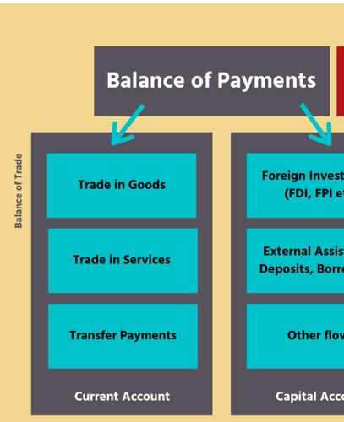

Balance of Payments (BoP) statistics systematically summarise, for a specific period, the economic transactions of an economy with the rest of the world.

The compilation and dissemination of BoP data is the prime responsibility of RBI.

BoP = net credit in ( Current Account + Capital Account and Financial Account).

[India’s Balance of Payments (BoP)](https://www.clearias.com/balance-of-payments/) position witnessed great improvement since liberalization in 1991.

India’s foreign reserves stood at US$ 572 billion as on November 2020.

Foreign Exchange (Forex) Reserves include Foreign Currency Assets, Gold,  Special Drawing Rights (SDRs), and Reserve Position in the IMF (Gold Tranche or Reserve Tranche).

## Global Trade

Global Trade was growing at 5.7 percent in 2017. However, in 2019-20, it is estimated to grow only at 1.0 percent.

## Ease of Doing Business: Performance of India

India now ranks 68 out of the 190 countries under the indicator “Trading across Borders” in the Ease of Doing Business Report published by the World Bank. (2019)

## Logistics Industry in India

The logistics industry of India is currently estimated to be around US$ 160 billion and is expected to reach US$ 215 billion by 2020.

## Net Remittances from Indians employed overseas

Net Remittances are part of the Current Account in the Balance of Payments statement published by RBI.

Net remittances from Indians employed overseas have been constantly increasing year after year.

## FDI Inflows and FPI Inflows

[FDI](https://www.clearias.com/foreign-direct-investment/) and FPI are showing a positive trend in recent years.

## External Debt

After witnessing a significant decline from 2014-15, India’s external liabilities (debt and equity) to GDP increased at the end of June 2019 primarily driven by an increase in FDI, portfolio flows, and external commercial borrowings (ECBs).

External debt as of the end of September 2019 remains low at 20.1 percent of GDP.

## Foreign Trade Policy of India

The Foreign Trade Policy, 2015-20,  notified by the Central Government, is an exercise of powers conferred under Section 5 of the Foreign Trade (Development & Regulation) Act, 1992 OR FT (D&R) Act.

## Who regulates Export Trade in India?

Export trade is regulated by the **Directorate General of Foreign Trade (**[**DGFT**](https://www.dgft.gov.in/CP/)**)** and its regional offices, functioning under the Ministry of Commerce and Industry, Department of Commerce, Government of India.

Policies and procedures required to be followed for exports from India are announced by the DGFT, from time to time.

# Reserve Bank of India

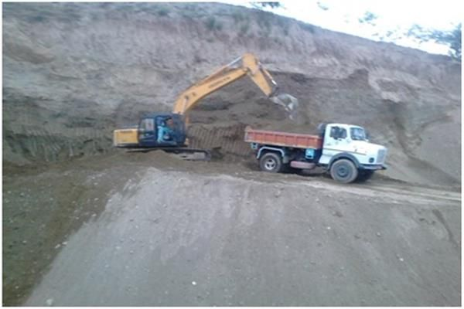

## What’s in today’s article?

* Why in the News?
* About Reserve Bank of India (RBI)
* Composition of the RBI
* Primary Functions of the RBI
* Journey of the RBI
* News Summary

## Why in the News?

* [**Prime Minister**](https://vajiramandravi.com/quest-upsc-notes/prime-minister/)Narendra Modi addressed a ceremony to mark 90 years of the Reserve Bank of India in Mumbai.

## About Reserve Bank of India (RBI)

* The Reserve Bank of India, abbreviated as RBI, is India's central bank and regulatory body responsible for regulation of the Indian banking system.
* It is responsible for the control, issue and maintaining supply of the Indian rupee.
* The RBI was established in 1934, under the **Reserve Bank of India Act**.

The bank was set up based on the recommendations of the 1926 Royal Commission on Indian Currency and Finance, also known as the **Hilton Young Commission**.

* Though privately owned initially, it was **nationalized in 1949** and since then fully owned by the Ministry of Finance, Government of India.

## Composition of the RBI

* The overall direction of the RBI lies with the **21-member central board of directors**, composed of:
  + One Governor;
  + Four Deputy Governors;
  + Two Finance Ministry Representatives (usually the Economic Affairs Secretary and the Financial Services Secretary);
  + Ten government-nominated Directors; and
  + Four Directors who represent local boards for **Mumbai**, **Kolkata**, **Chennai**, and **Delhi**.
  + Each of these local boards consists of five members who represent regional interests and the interests of co-operative and indigenous banks.
  + The first Governor of the RBI was the Australian Sir Osborne Arkell Smith. **Sir C D Deshmukh** was the first Indian to become Governor.

## Primary Functions of the RBI

* **Monetary Authority:**
  + Formulates, implements and monitors the monetary policy.
  + **Objective**: maintaining price stability while keeping in mind the objective of growth.
* **Regulator and Supervisor of the Financial System:**
  + Prescribes broad parameters of banking operations within which the country's banking and financial system functions.
  + **Objective**: maintain public confidence in the system, protect depositors' interest and provide cost-effective banking services to the public.
* **Manager of Foreign Exchange:**
  + Manages the [Foreign Exchange Management Act](https://vajiramandravi.com/upsc-daily-current-affairs/prelims-pointers/fema/), 1999.
  + **Objective**: to facilitate external trade and payment and promote orderly development and maintenance of foreign exchange market in India.
* **Issuer of Currency:**
  + Issues, exchanges and destroys currency notes as well as puts into circulation coins minted by Government of India.
  + **Objective**: to give the public adequate quantity of supplies of currency notes and coins and in good quality.
* **Developmental Role:**
  + Performs a wide range of promotional functions to support national objectives.
* **Regulator and Supervisor of Payment and Settlement Systems:**
  + Introduces and upgrades safe and efficient modes of payment systems in the country to meet the requirements of the public at large.
  + **Objective**: maintain public confidence in payment and settlement system
* **Related Functions:**
  + Banker to the Government: performs merchant banking function for the central and the state governments; also acts as their banker.
  + Banker to banks: maintains banking accounts of all scheduled banks.

## Journey of the RBI

* **1935-1949**:
  + The Reserve Bank of India was founded on 1 April 1935 to respond to economic troubles after the First World War.
  + India was the first colony to have its own central bank.
* **1950-1960**:
  + In the 1950s, the Indian government developed a centrally planned economic policy that focused on the agricultural sector.
  + The administration nationalized commercial banks and established, based on the Banking Companies Act, 1949, a central bank regulation as part of the RBI.
  + Furthermore, the central bank was ordered to support economic plan with loans.
* **1961-1968**:
  + As a result of bank crashes, the RBI was requested to establish and monitor a deposit insurance system.
  + The government of India restructured the national bank market and nationalized a lot of institutes.
  + As a result, the RBI had to play the central part in controlling and supporting this public banking sector.
* **1969-1984**:
  + In 1969, the Indira Gandhi-headed government nationalized 14 major commercial banks.
  + The central bank became the central player and increased its policies a lot for various tasks like interests, reserve ratio and visible deposits.
* **1985-1990**:
  + The Indian financial market was a leading example for so-called "financial repression".
  + The Discount and Finance House of India began its operations in the monetary market in April 1988; the National Housing Bank, founded in July 1988, was forced to invest in the property market and a new financial law improved the versatility of direct deposit by more security measures and liberalisation.
* **1991-1999**:
  + The national economy contracted in July 1991 as the Indian rupee was devalued.
  + The currency lost 18% of its value relative to the US dollar, and the **Narsimham Committee** advised restructuring the financial sector by a temporal reduced reserve ratio as well as the statutory liquidity ratio.
  + New guidelines were published in 1993 to establish a private banking sector.
  + The central bank deregulated bank interests and some sectors of the financial market like the trust and property markets.
* **2000-2009**:
  + The Foreign Exchange Management Act, 1999 came into force in June 2000.
  + The national economy's growth rate came down to 5.8% in the last quarter of 2008–2009 and the central bank promotes the economic development.
* **Since 2010**:
  + In 2016, the Government of India amended the RBI Act to establish the [Monetary Policy Committee (MPC)](https://vajiramandravi.com/upsc-daily-current-affairs/prelims-pointers/what-is-the-monetary-policy-committee-mpc/) to set.
  + This limited the role of the RBI in setting interest rates, as the MPC membership is evenly divided between members of the RBI (including the RBI governor) and independent members appointed by the government.
  + In April 2018, the RBI announced that "entities regulated by RBI shall not deal with or provide services to any individual or business entities dealing with or settling virtual currencies," including **Bitcoin**.

### News Summary

* The Prime Minister, Shri Narendra Modi addressed the opening ceremony of **RBI@90**, a program marking 90 years of the Reserve Bank of India, in Mumbai.
* Addressing the occasion, the Prime Minister said that the Reserve Bank of India has reached a historic landmark today completing 90 years of existence.
* He underlined that the RBI has witnessed both the pre- and post-independence eras and it has created an identity around the world based on its professionalism and commitment.
* “The next decade is extremely important for the resolutions of a Viksit Bharat”, PM Modi said, highlighting the RBI’s priority towards fast-paced growth and focus on trust and stability.
* Prime Minister Modi pointed out that even though the discussions related to the RBI are often limited to financial definitions and complex terminologies, the work carried out at RBI directly makes an impact on the lives of common citizens.
* The Prime Minister emphasized the importance of clarity for the targets of the next 10 years.
* He pointed out the importance of keeping an eye on the changes brought about by the cashless economy while promoting digital transactions.
* He also stressed the need for deepening financial inclusion and empowerment processes.
* Noting that India is the most youthful nation in the world today, the Prime Minister touched upon RBI playing a critical role in fulfilling the aspirations of the youth.
* PM Modi underlined the importance of a strong Banking industry for providing required funding to the projects of the nation.

He noted the changes brought about by technologies like AI and BlockChain and noted the importance of cyber security in the growing digital banking system.

Nationalization refers to the transfer of public sector assets to be operated or owned by the state or central government. In India, the banks which were previously functioning under the private sector were transferred to the public sector by the act of nationalization and thus the nationalized banks came into existence.

**Reasons for the Nationalization of Banks**

* For Social Welfare
* For Developing Banking Habits
* For Expansion of Banking Sector
* For Controlling Private Monopolies
* To Reduce Regional Imbalance
* For Prioritizing Sector Lending

The government through the Banking Companies (Acquisition and Transfer of Undertakings) Ordinance, 1969, and nationalized the 14 largest commercial banks on 19 July 1969. These lenders held over 80 percent of bank deposits in the country. Soon, the parliament passed the Banking Companies (Acquisition and Transfer of Undertaking) Bill, and it received presidential approval on 9 August 1969.

The banks that were nationalized included Allahabad Bank, Bank of Baroda, Bank of India, Bank of Maharashtra, Central Bank of India, Canara Bank, Dena Bank, Indian Bank, Indian Overseas Bank, Punjab National Bank, Syndicate Bank, UCO Bank, Union Bank and United Bank of India.

Thereafter, in 1980, six more banks that were nationalized included Punjab and Sind Bank, Vijaya Bank, Oriental Bank of India, Corporate Bank, Andhra Bank, and New Bank of India.

Nationalization refers to the transfer of public sector assets to be operated or owned by the state or central government. In India, the banks which were previously functioning under the private sector were transferred to the public sector by the act of nationalization and thus the nationalized banks came into existence.

**Reasons for the Nationalization of Banks**

* For Social Welfare
* For Developing Banking Habits
* For Expansion of Banking Sector
* For Controlling Private Monopolies
* To Reduce Regional Imbalance
* For Prioritizing Sector Lending

The government through the Banking Companies (Acquisition and Transfer of Undertakings) Ordinance, 1969, and nationalized the 14 largest commercial banks on 19 July 1969. These lenders held over 80 percent of bank deposits in the country. Soon, the parliament passed the Banking Companies (Acquisition and Transfer of Undertaking) Bill, and it received presidential approval on 9 August 1969.

The banks that were nationalized included Allahabad Bank, Bank of Baroda, Bank of India, Bank of Maharashtra, Central Bank of India, Canara Bank, Dena Bank, Indian Bank, Indian Overseas Bank, Punjab National Bank, Syndicate Bank, UCO Bank, Union Bank and United Bank of India.

Thereafter, in 1980, six more banks that were nationalized included Punjab and Sind Bank, Vijaya Bank, Oriental Bank of India, Corporate Bank, Andhra Bank, and New Bank of India.

## **National Stock Exchange of India**

Image source: www.nseindia.com

The largest financial market in India and the fourth largest market in the world by trading volume is the National Stock Exchange of India Limited (NSE).

* To increase openness in the Indian equities markets, the National Stock Exchange was **founded in 1992.**
  + It was incorporated in 1992.
  + NSE was recognised as a stock exchange by SEBI in 1993.
  + It commenced operations in 1994.
* It was the first exchange in India to offer contemporary, fully automated electronic trading (in 1994).
* The National Stock Exchange of India Limited (NSE), which has its headquarters in Mumbai, carries out trades in the wholesale debt, stock, and derivative markets.
* It permits overseas businesses seeking to raise capital in India to conduct fresh listings, [initial public offerings (IPOs)](https://byjus.com/free-ias-prep/initial-public-offering-ipo/), debt issuances, and the issuance of Indian Depository Receipts (IDRs).
* NSE launched the Nifty 50 index in 1996. Know more about the [Nifty 50 index](https://byjus.com/full-form/nifty-full-form/) in the link.
* NSE offers products in three categories as follows:
  + Equity and equity-linked products available for trading in the cash market include stocks, IDRs, [Exchange Traded Funds](https://byjus.com/free-ias-prep/exchange-traded-funds/), units of closed-ended mutual fund schemes, etc.
  + Fixed income securities and debt products such as Negotiated Trade Reporting in Government securities, Corporate Bonds, [Sovereign Gold Bonds](https://byjus.com/free-ias-prep/sovereign-gold-bond-scheme/), etc.
  + Under the Derivatives segment, NSE offers derivative contracts on Equity, Indices, Currency, Interest Rates and Commodities.

**NSE Purpose:**

Committed to improve the financial well-being of people.

**NSE Vision:**

To continue to be a leader, facilitate the financial well-being of people.

**NSE Values:**

NSE is committed to core values – Integrity, Customer Focused Culture, Trust, Respect and Care for the Individual, Passion for Excellence, Teamwork.

### **What are Equity Shares?**

An equity share, normally known as the ordinary share is a part ownership where each member is a fractional owner and initiates the maximum entrepreneurial liability related to a trading concern. These types of shareholders in any organization possess the right to vote.

* Equity share capital remains with the company. It is given back only when the company is closed.
* Equity shareholders possess voting rights and select the company’s management.
* The dividend rate on the equity capital relies upon the obtainability of the surfeit capital. However, there is no fixed rate of dividend on the equity capital.